

Enterprise Storage

WFA OpenStack Workflow Implementation

Synopsis: Cloud Integration with WFA for storage provisioning including decision making.

Segment: DCO

Authors: David Ellis

Contributors:

Document Version: [V1.0]
Date: 3/3/2015
Document Status: Issued

CONFIDENTIAL INFORMATION
This document contains information proprietary to Thomson Reuters and may not be reproduced, disclosed or used in whole or part without express permission of Thomson Reuters.

© Thomson Reuters 2010
Contents
1 Introduction 3
Management Summary 3
Assumptions 3
Change History 3
Distribution List 3
2 Preparing WFA Datasource 4
Create unique OCUM group 4
Add members to OCUM group 4
3 Define WFA user accounts and credentials 5
Create WFA user account 5
Create WFA Localhost credential 6
4 Define Custom Datasource 7
Create a new dictionary entry 7
Create new schema 7m_snapshot 7
Create new Data Source Type. 8
5 Aquire Custom DataSource 9
Add DataSource to WFA 9
6 Import Openstack Workflows 11

Introduction

Management Summary
This document is intended to provide engineers with a proven step by step process to successfully integrate the open stack workflows with WFA. The document covers creating custom data sources, importing workflows, creating new users and credentials. All of these tasks are relevant WFA administration examples that could also apply outside of this particular implementation.

Assumptions
The document assumes users are familiar with the administration and utilization of NetApp OCUM and the reader also has a general understanding of WFA and is familiar with its menus.

Change History
Ver | Date | Author | Key Changes
1.0 | 03/03/15 | David Ellis | [First Draft]

Distribution List
Name | Role
Storage Support Team | Storage Support Engineers
Brett Truhler | DCO Storage Architect

Preparing WFA Datasource
The filter utilized in the create share workflow requires a unique group be defined on the OCUM instance. This group should contain all vfilers, root aggregates, data aggregates and controllers which can be utilized for cloud deployment. This group should not contain vservers which are being utilized for vlan tagging, i.e vsip-2506.

Create unique OCUM group
At the time this document was written the group being created on the OCUM instance is simply defined as openstack. If it is later determined the group should be placed in the existing filers group the engineer will need to make sure this is reflected in the create share workflow or it will fail.
Dfm group create openstack-<location>
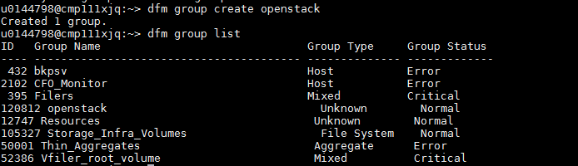

Add members to OCUM group
DFM group add openstack-<location> <element>
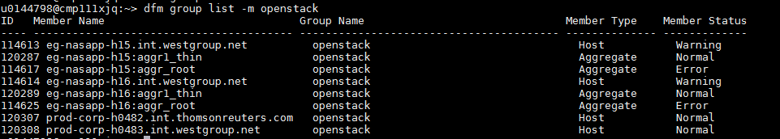

Define WFA user accounts and credentials
The manila service requires a few user accounts to be in place which allow for administrative calls to the wfa service via API. There is also a local host account created to allow for creation of an input file which will later be utilized to populate a custom data source.

Create WFA user account
Click the execution tab, select users click add new user. This will need to be repeated for each user in the table below.
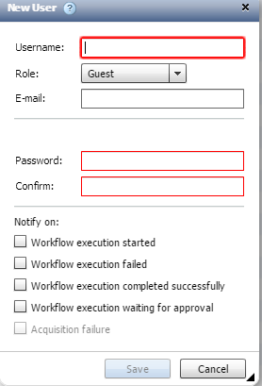
Require user accounts
Username | Password | Role
Manila | Netapp | Admin
Manila_wfa | Netapp | Operator
Wfa | Netapp | Admin

Create WFA Localhost credential
Access to the localhost requires appropriate credentials to be defined within WFA. To create the credentials click Execution, credentials, then select the icon to define a new set.
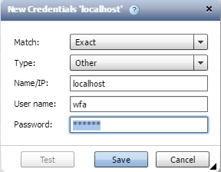
Click save after entering the apropriate parameters.

Define Custom Datasource
Many of the workflows to be utilized by the manila service require a custom data source 7m_snapshot_info. The data source tracks, snapshot names, array names, and volume names. The custom data source is local to the deployed WFA instance.

Create a new dictionary entry
New dictionary entries allow developers to add custom tables to the WFA SQL database.
Click the designer tab then select dictionary, click create new.
Enter the following information into the appropriate fields.
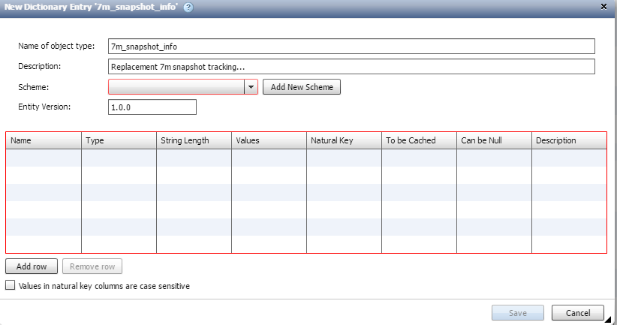

Create new schema 7m_snapshot
Each dictionary entry requires a schema to be defined which identifies the rows within the new table. Click add new scheme to continue. Then add the following information
Name | Type | String Length | Selected Options
Snapshot_name | String | 255 | Natural Key/To be Cached
Array | String | 255 | Natural Key/To be Cached
Volume | String | 255 | Natural Key/To be cached

Click Save after the appropriate parameters have been defined.
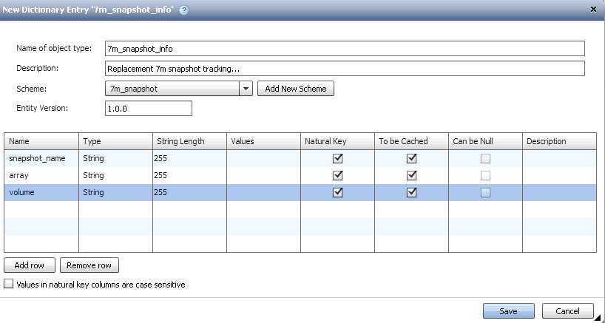

Create new Data Source Type.
A new data source type, 7m_snapshot needs to be created which will utilize the newly defined schema. To begin click new, then enter the following values for the appropriate fields.
Data Source Type | Scheme | Method
7m_snapshot | 7m_Snapshot | Script*
*The script needs to be copied and pasted into the script box, it can be found on the storage share ,sg$ in the directory,\WFA Build 2.2.1RC1\Cloud workflows\7m_snapshot_script.txt
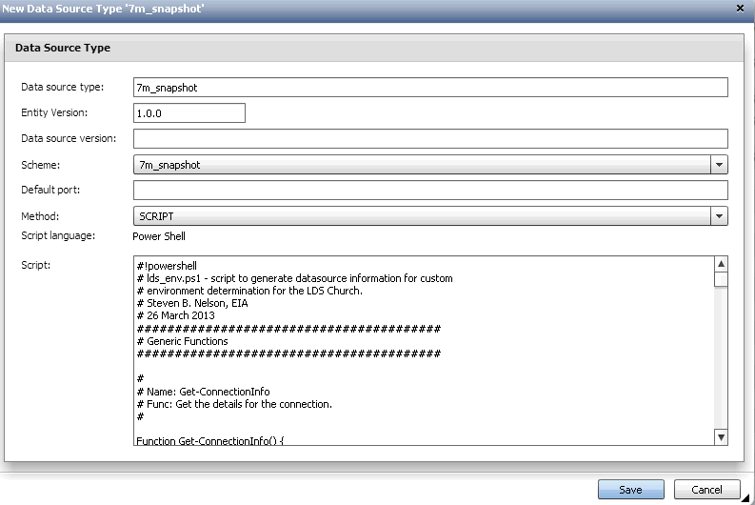
Click Save when complete.

Aquire Custom DataSource
The Custom Data Source imports its data from file which is created in the folder, config_input in the /Netapp/WFA directory on the server hosting the WFA instance. This directory is not standard and must be defined.
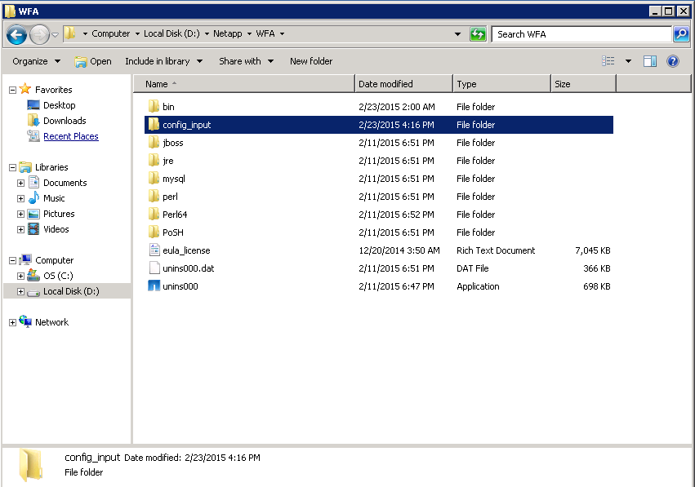

Add DataSource to WFA
With the creation of all the necessary components to house the custom Data Source the final step is to acquire the data source or add it to WFA.
Navigate to the Execution Tab, Click Data Sources, then New. Enter the following details.
Name | Data source type | Host name | Port
7m_snapshot | 7m_snapshot | Localhost | 443
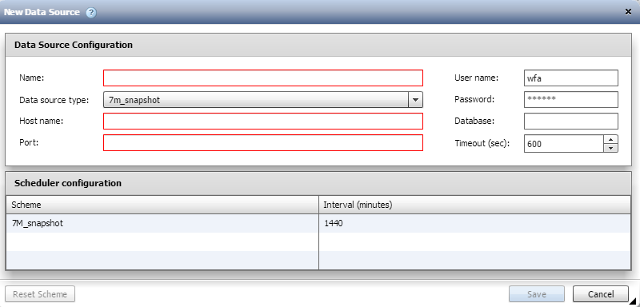
Click save when complete.
*When first aquiring the data source it will result in an error as the snapshot table csv doesn’t exist until the first snapshot is taken with the system.

Import Openstack Workflows
The final step in deploying a WFA instance for use integration with Openstack and manila is to deploy the designed workflows. The active workflows include the following.
- Os_create_nfs_share_7m
- Os_create_snapshot_7m
- Os_delete_snapshot_7m
- Os_delete_nfs_share_7m
It is important that the names of these workflows remain consistent across all WFA deployments.
Click Administration, then import.
The OS_Workflows_Category is being kepet on the storage SG$ share in the directory \WFA Build 2.2.1RC1\Cloud Workflows
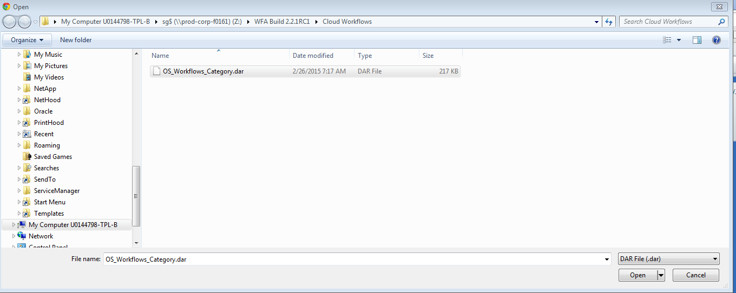
Select the appropriate file and click Open.
When the category has been imported correctly it will appear in the sliding menu on the left of the WFA instance.
